Practical - 4
Practical Title: JavaScript DOM Manipulation, Event Handling, and UI Interactivity
Problem Definition 4: Add dynamic UI components such as collapsible FAQ, modal popup, image/content slider, notification banner, hamburger menu, and light/dark theme switcher using JavaScript.
- How does the layout adapt for mobile, tablet, and desktop screens?
The layout is responsive, so it adjusts according to the screen size. On mobile, the content is arranged in a single column. On tablets and desktops, more content can fit side by side.
- Which layout technique is used and why?
Flexbox/Grid is used to arrange the elements. It makes the website easier to organize and helps the layout adjust to different screen sizes.
- Are typography, spacing, colors, and contrast readable?
Yes, the text is easy to read. Proper spacing is given between elements, and the colors have enough contrast so that the content is clearly visible.
- Is the framework used consistently without unnecessary inline CSS?
Yes, the framework is used consistently. Most of the styling is done using classes instead of writing unnecessary inline CSS, which keeps the code clean and easy to manage.

Implementation/ Output/Result (Keep only one option which is suitable to practical)
Summary of script.js
This JavaScript file is used to add interactive features to the StudentHub Portal website.
- Theme Switcher – Allows the user to switch between Dark Mode and Light Mode. The selected theme is saved in localStorage.
- Hamburger Menu – Opens and closes the navigation menu when the hamburger button is clicked, mainly useful for smaller screens.
- Notification Banner – Allows the user to close a notification banner. The closed status is saved so the banner stays hidden when the page is opened again.
- FAQ Accordion – When a user clicks an FAQ question, its answer opens or closes. It also updates the aria-expanded value.
- Modal Popup – Opens a popup when a button is clicked. The popup can be closed using the close button or by clicking outside the popup.
- Slider – Creates an image/content slider with Next and Previous buttons. It also automatically changes the slide every 5 seconds.
Overall: This JavaScript makes the StudentHub website interactive, responsive, and user-friendly by controlling themes, menus, notifications, FAQs, popups, and sliders.

Evidence of Work (Screenshots):
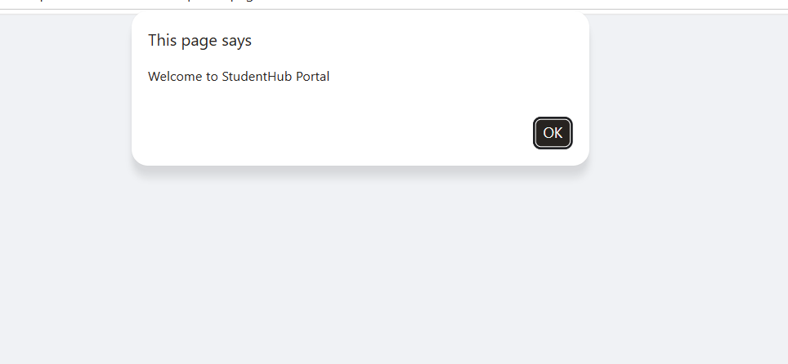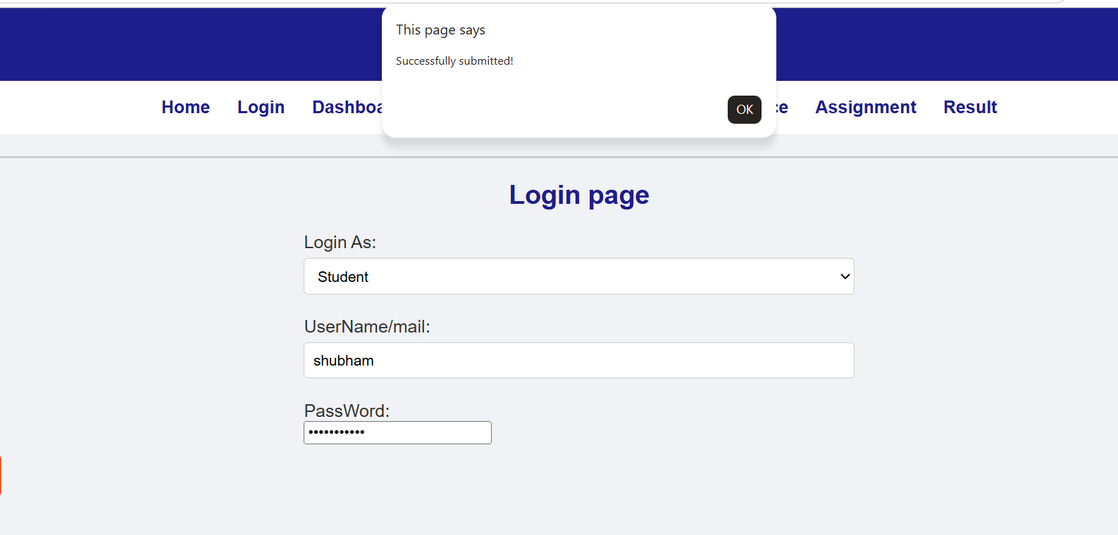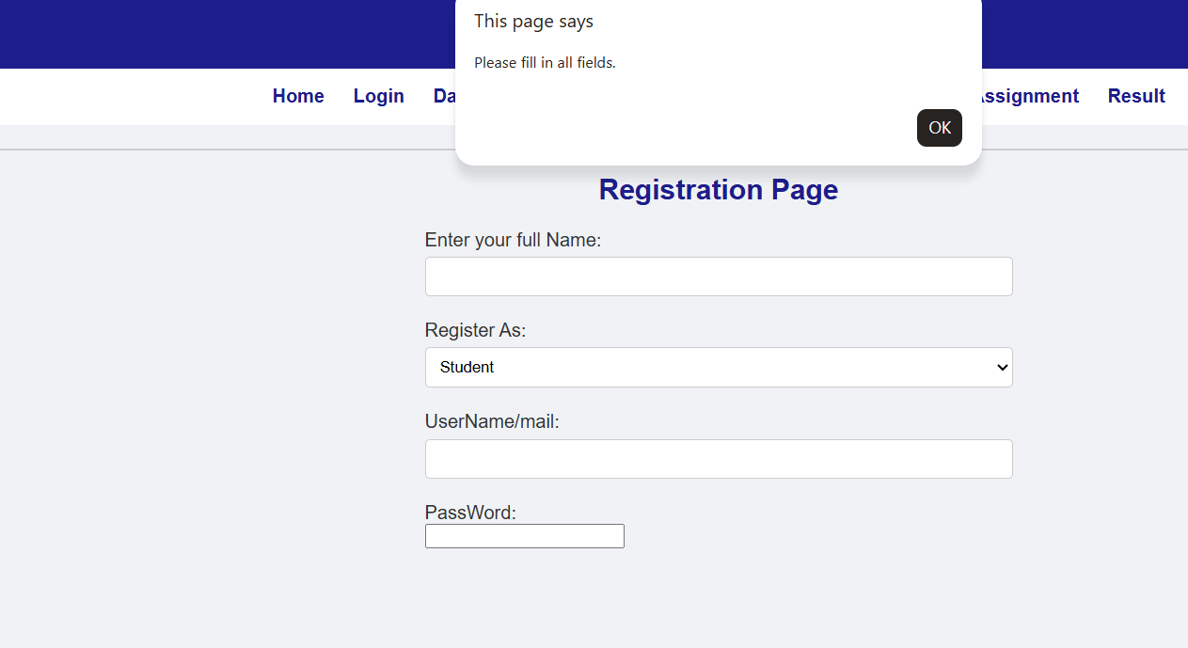
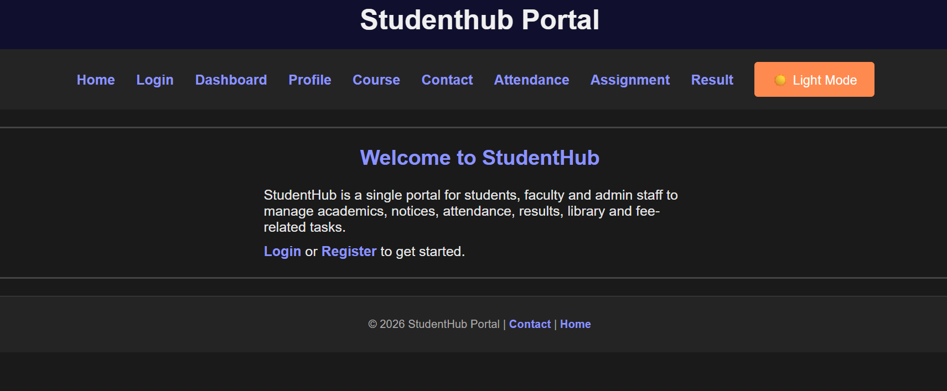
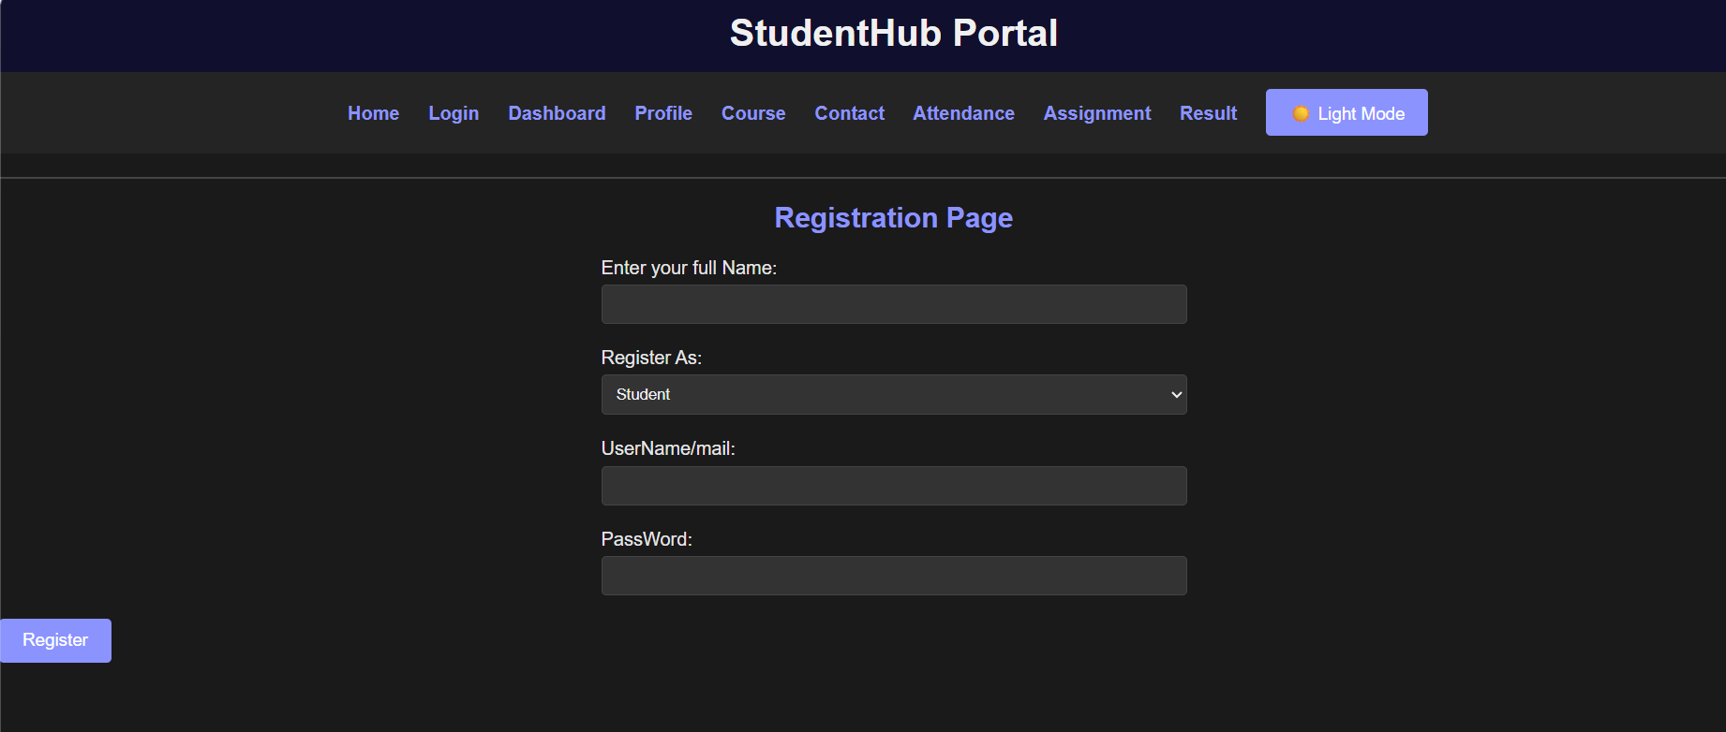
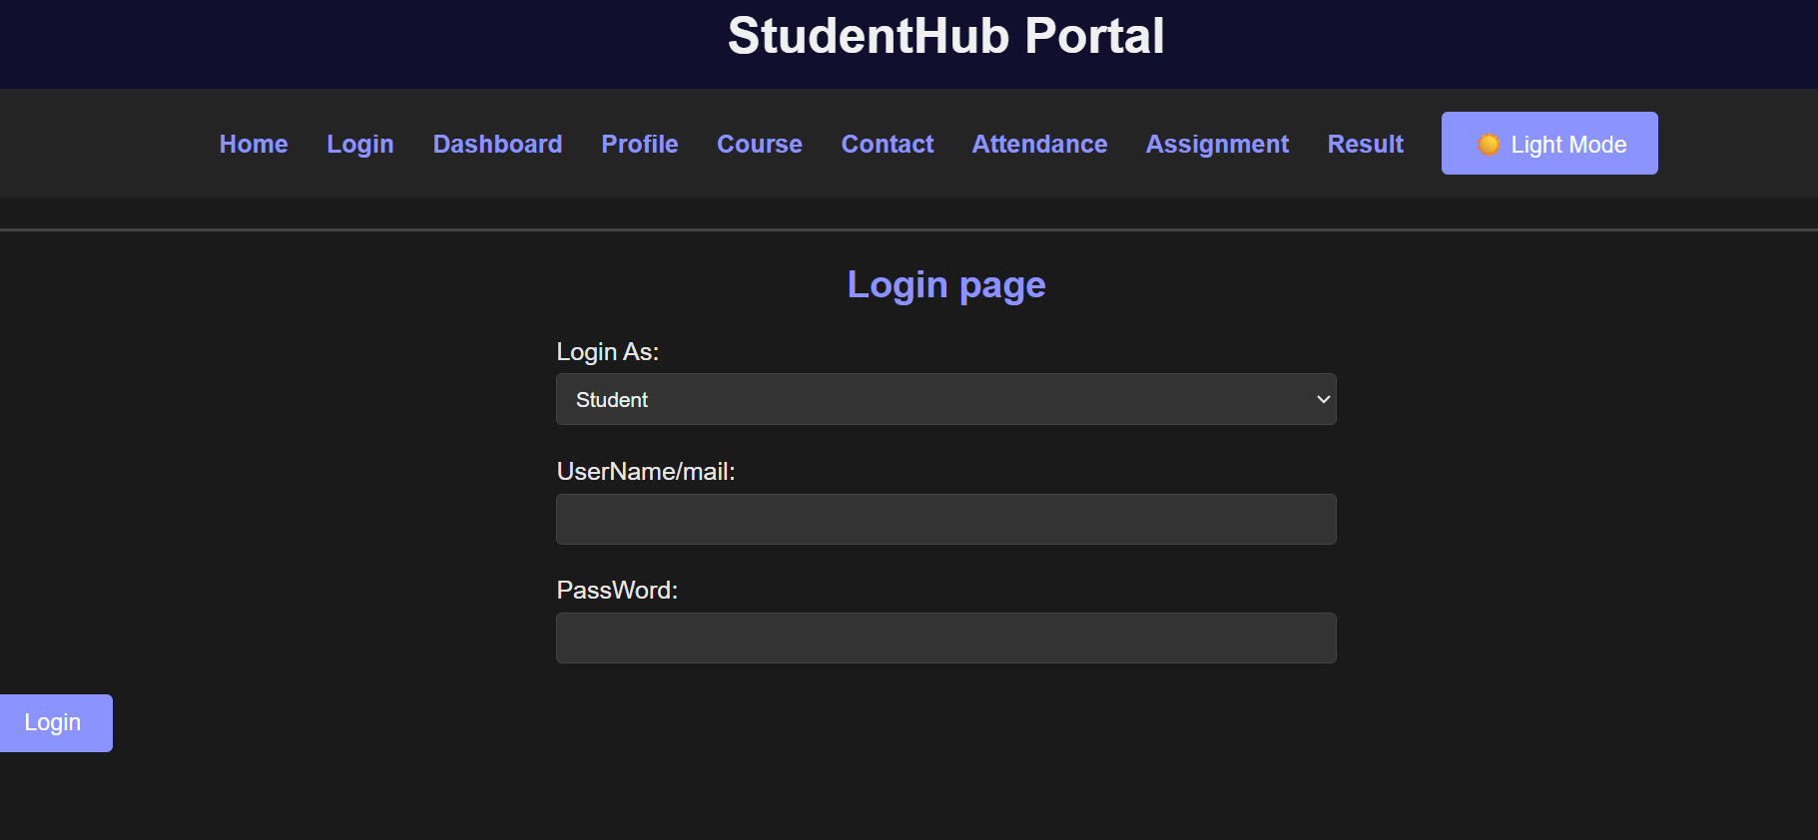
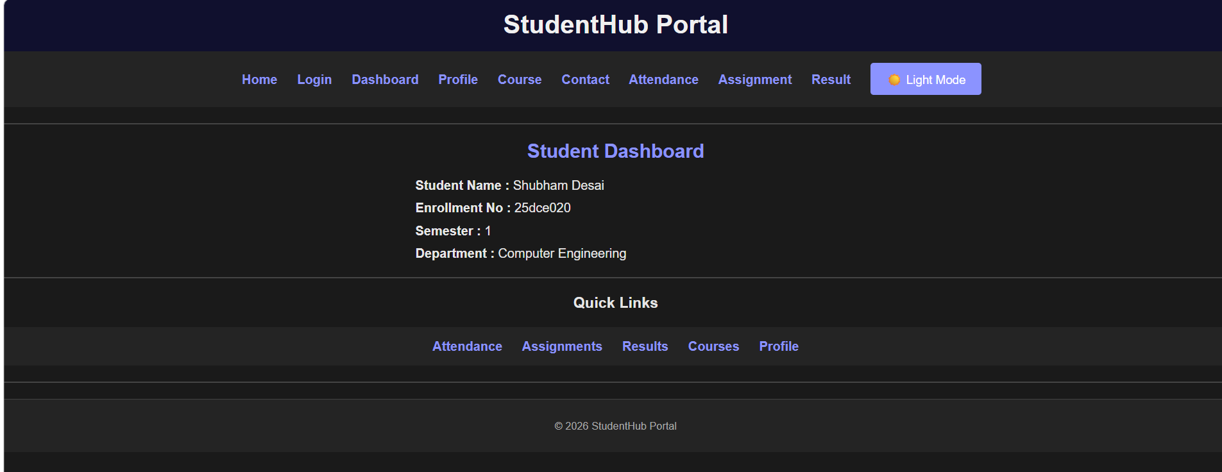
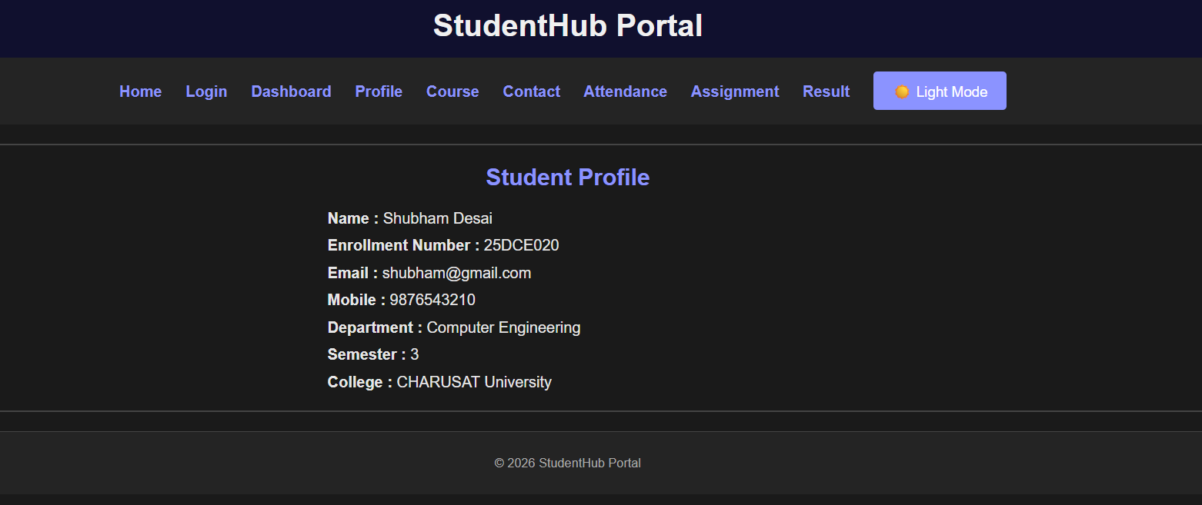
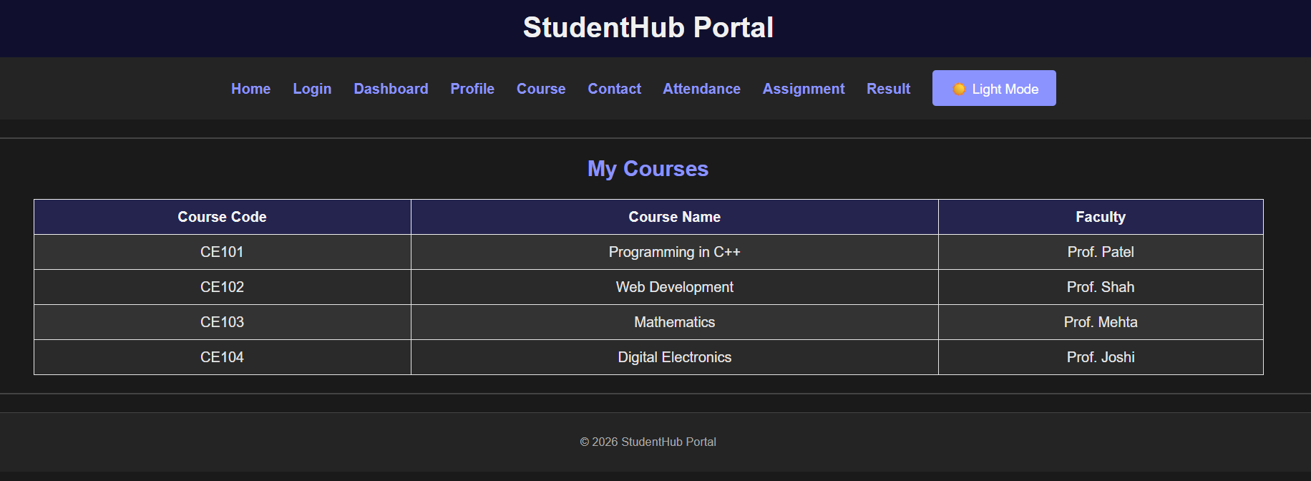
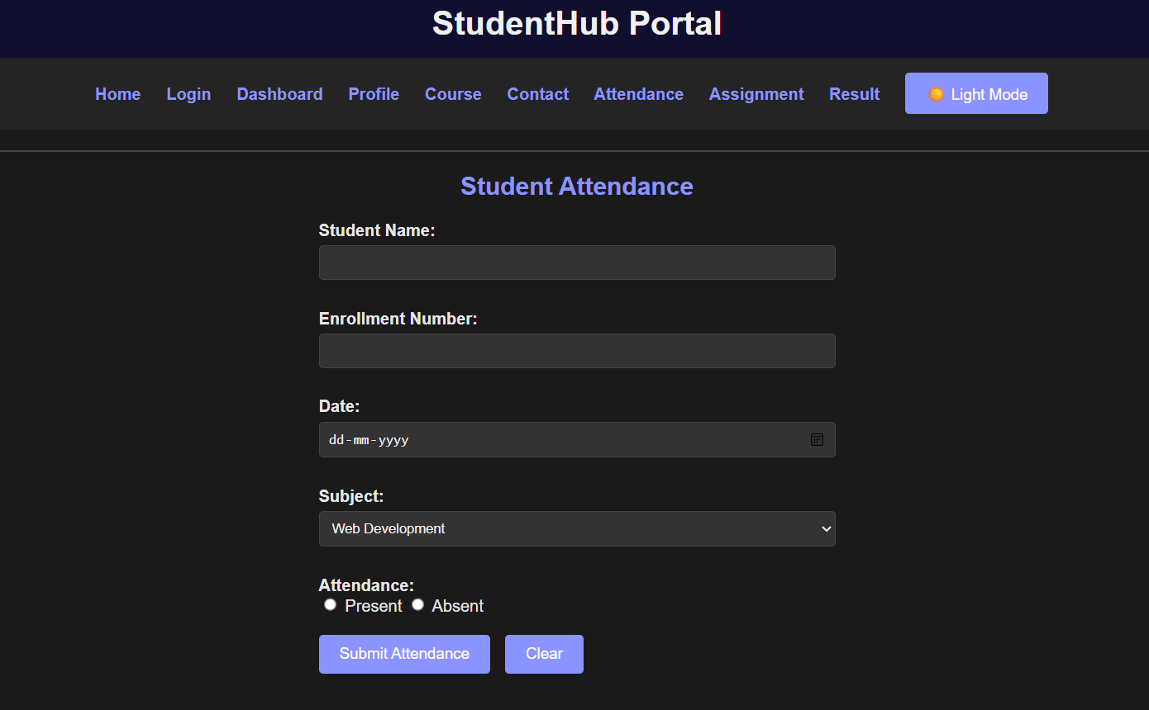
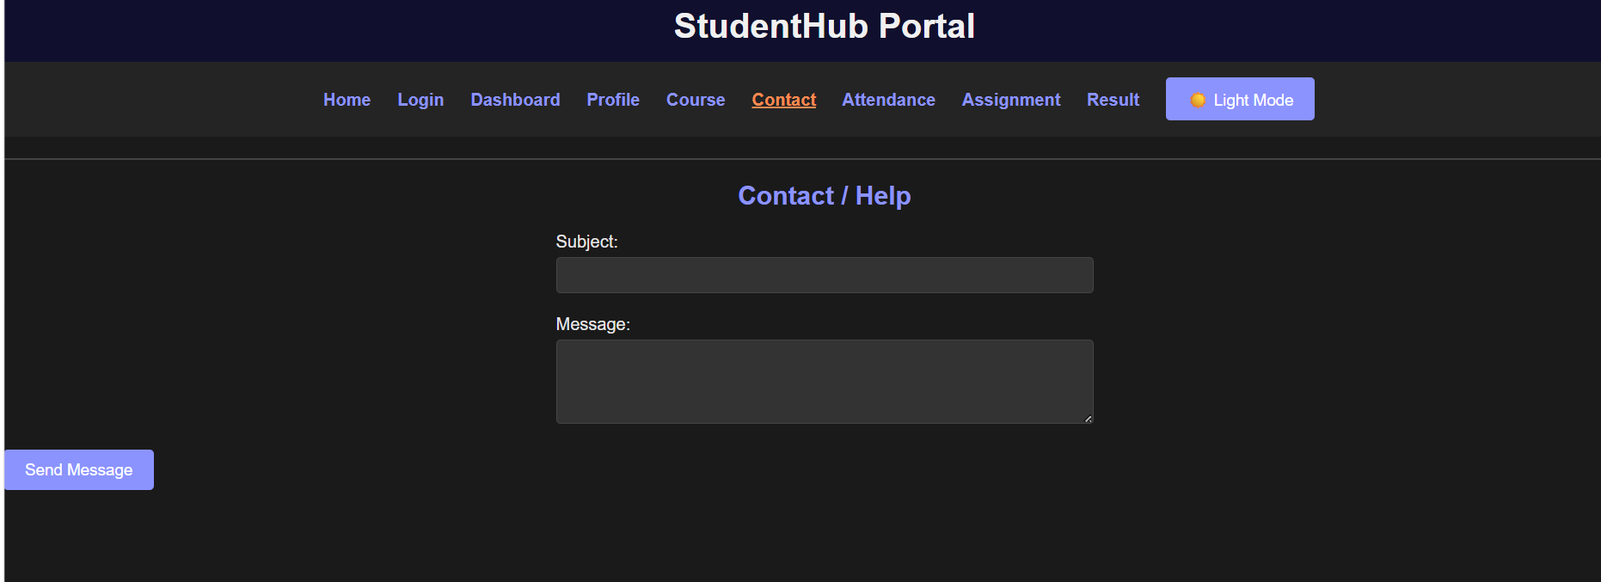
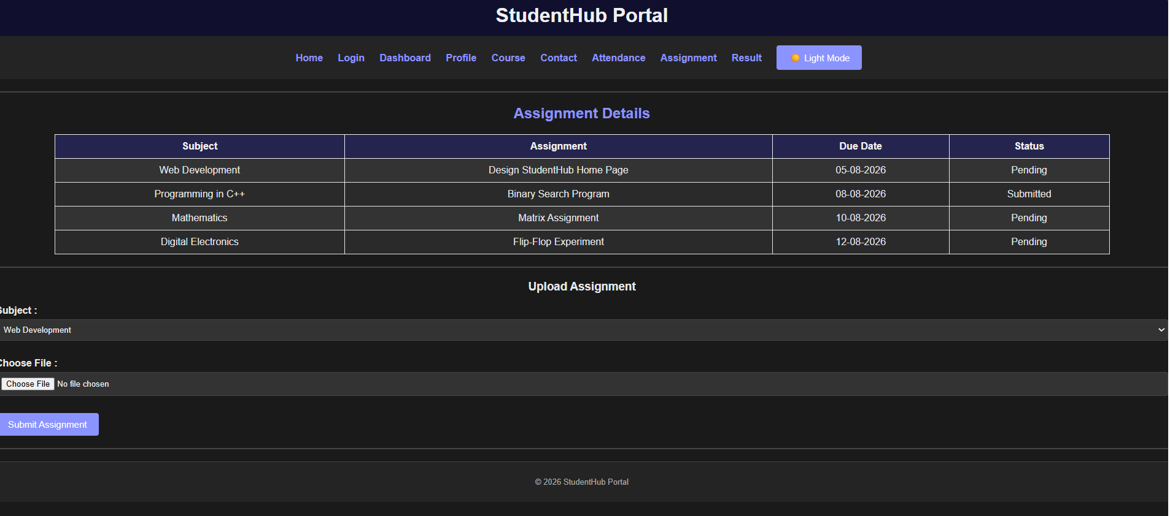
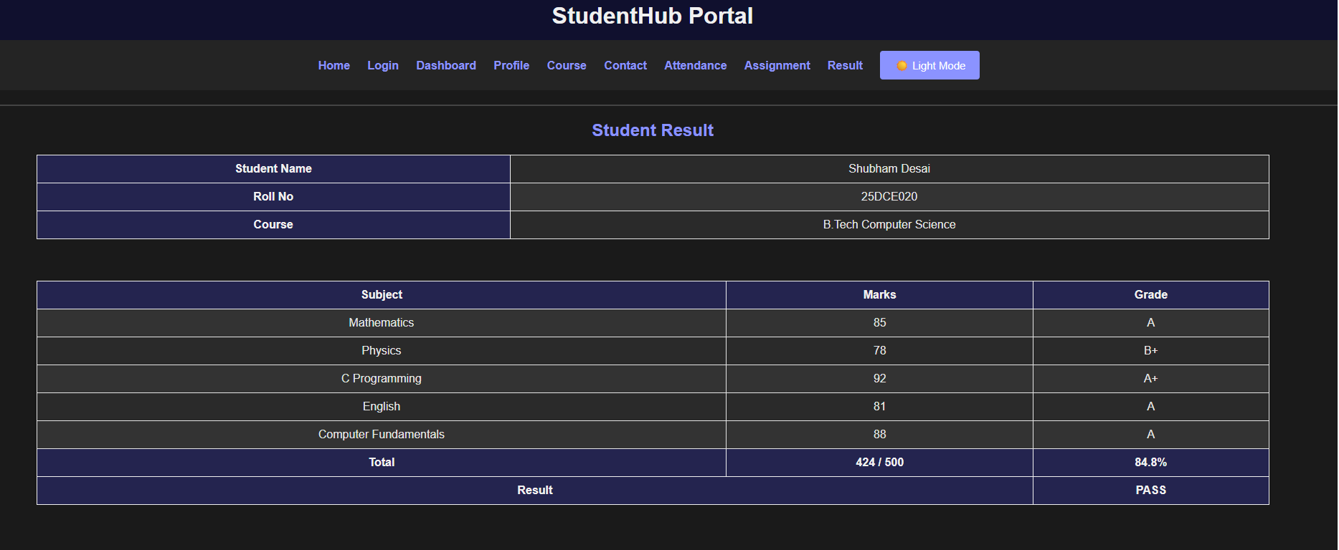

GitHub Repository Link:
https://github.com/Shubham-desai07/Studenthub-portal.gi
- Challenges Faced:
• Understanding how to use JavaScript DOM methods like getElementById() and querySelector().
• Handling button click events using addEventListener().
• Implementing the Dark Mode and saving the selected theme using localStorage.
• Creating the hamburger menu and showing or hiding the navigation list.
• Managing the FAQ accordion so that answers open and close when clicked.
• Understanding how to open and close modal popups using classes.
• Implementing the slider and making it automatically change every 5 seconds.
• Making sure the JavaScript does not give errors when some elements are not present on a particular HTML page.

Learning Outcomes

Learned how to use JavaScript to make a website interactive.

Learned how to handle button click events using addEventListener().

Learned how to access and change HTML elements using DOM methods.

Learned how to use localStorage to save user preferences.

Learned how to create features like Dark Mode, hamburger menu, FAQ accordion, modal popup, and slider.

Improved understanding of JavaScript functions, loops, conditions, and variables.

Learned how JavaScript can improve the user experience of a website.

Faculty Remarks: (Keep this blank for faculty)

